TASK 1 – Environment Setup

- Configuration of User Profile
- Initialization of User Terminal

TASK 2 – Working DOCKER Images and NGC Container

- Login to the NGC Dashboard
- Generation of NGC Organization API Key
- Verification of Existing Docker Images (Before Pulling GitHub and Friend Images)
- Pulling and Executing the TensorFlow Container
- Pulling and Executing the PyTorch Container
- Pulling and Running a Use-Case-Based Container

TASK 3 – Installation and Pulling Packages from DOCKER Hub

- Pushing the Self Project Image to Docker Hub
- Pulling and Running the Self Project Image
- Pulling and Running a Friend’s Docker Image
- Verifying the Docker Images List After All Pull Operations

TASK 4 – Implementing and Executing Kubernetes

- Verification of Nodes and Pods After Minikube Installation
- YAML Configuration for Pulling and Deploying the Self Project Image
- Deployment Scaling (Upscaling and Downscaling)
- Creation of Secret YAML and Deployment Using Secrets
- Verification and Execution of Secrets
- Scaling Operations on Secret-Based Deployment (Upscale & Downscale)
- Final Deployment Overview and Pod Status Verification

Oracle VM VirtualBox is a virtualization application that allows users to operate multiple operating systems on a single computer. In this setup, Ubuntu Linux was installed within VirtualBox to establish a virtual Linux environment. This environment is used to:

- Practice operating system and command-line operations
- Create a secure and isolated testing platform

Installing Oracle VirtualBox

Steps:

1: Go to https://www.virtualbox.org
2: Download the installer for Windows hosts.
3: Open the installer file and click Next to begin setup.
4: Leave the default configuration settings and proceed with installing all required components.
5: Approve the installation of the network drivers when prompted.
6: Click Finish to complete the installation process.

Download Ubuntu

Steps:

1: Visit https://ubuntu.com/download/desktop\

2: Download the Ubuntu 22.04 LTS ISO file.

Creating Ubuntu Virtual Machine

Steps:

1: Launch VirtualBox and select New.

2: Provide the following details:
- Name: Ubuntu
- Type: Linux
- Version: Ubuntu (64-bit)
3: Assign memory (RAM):
- Minimum: 2048 MB
- Recommended: 4096 MB
4: Set up a virtual hard disk:
- Disk Type: VDI (VirtualBox Disk Image)
- Storage Allocation: Dynamically allocated
- Disk Size: Between 20–25 GB

Installing Ubuntu

Steps:

1: Choose the created virtual machine and click Start.
2: Select the downloaded Ubuntu ISO file when prompted.
3: Click on Install Ubuntu.
4: Choose the Normal Installation option.
5: Select Erase disk and install Ubuntu (this will only modify the virtual disk, not your actual system).
6: Create a username and set a password.
7: Wait until the installation finishes, then restart the virtual machine.
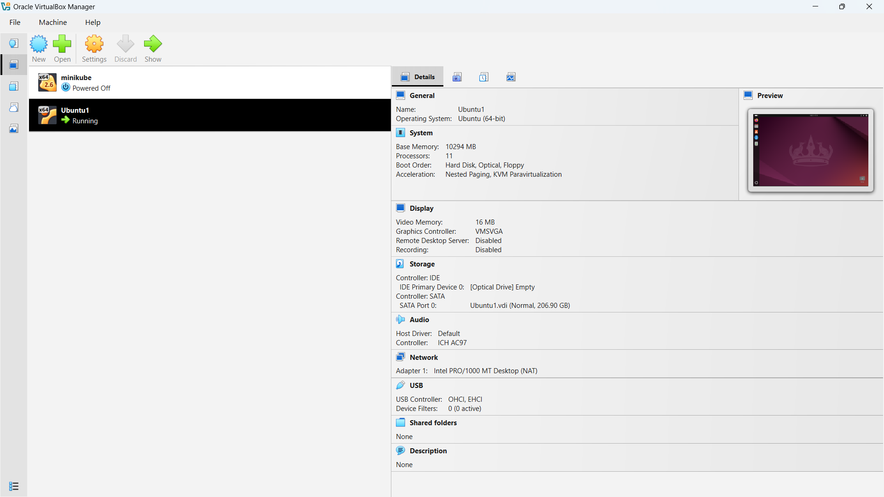
Figure 1: Ubuntu OS installed in a VM

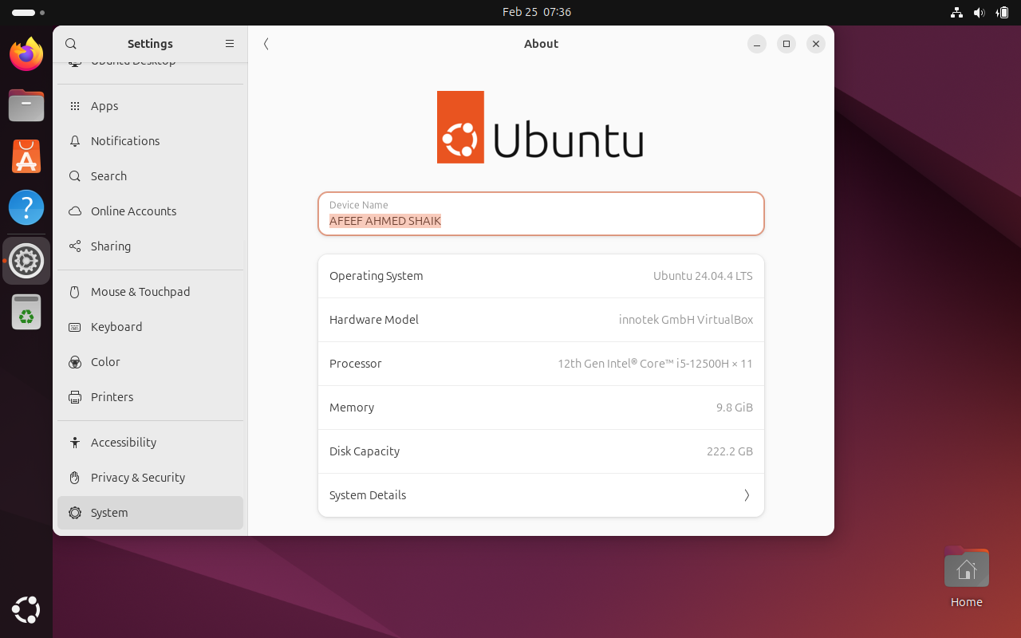
Figure 2: USER PROFILE

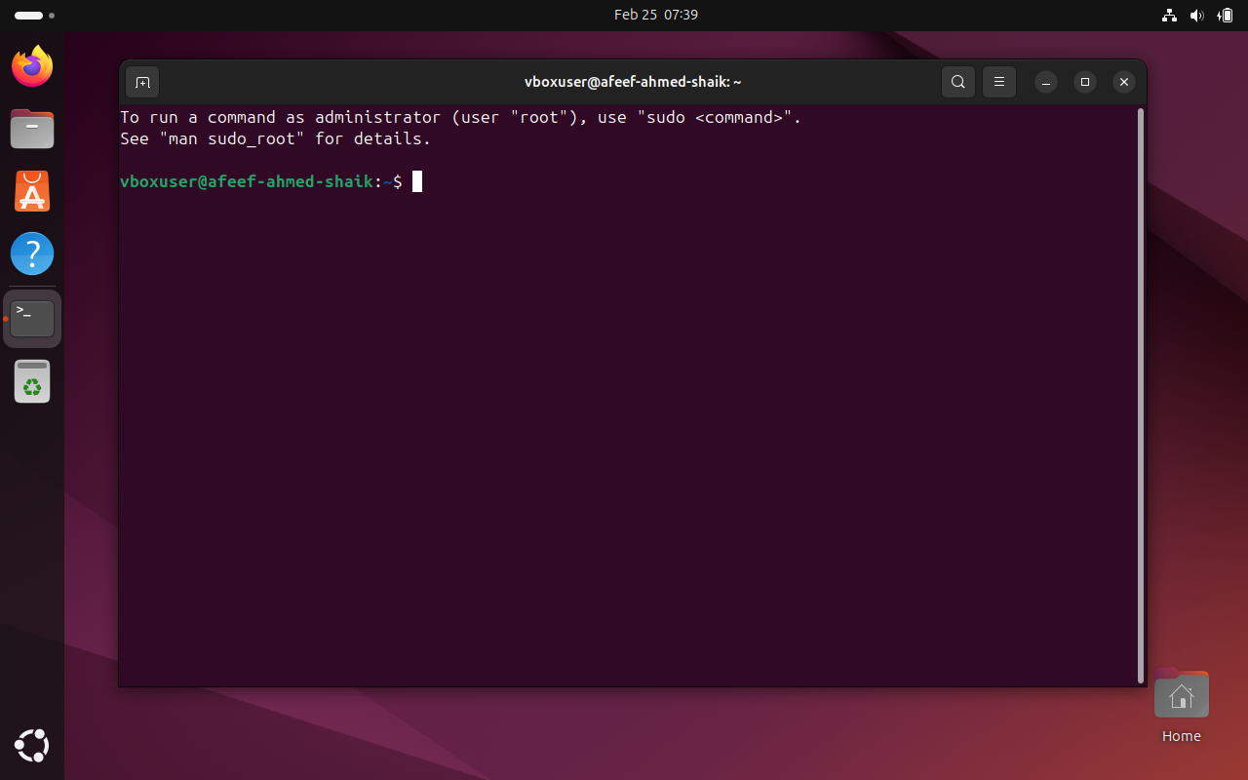
Figure 3: USER TERMINAL

NVIDIA NGC Login and API Key Generation

An NVIDIA NGC account was created to access GPU-enabled containers available in the NVIDIA Container Registry. An API key was generated and used to authenticate Docker, allowing the system to download NGC containers securely.

Step 1: Create NVIDIA NGC Account
- Open a web browser.
- Go to: https://ngc.nvidia.com
- Click on Sign In.
- Choose Create Account.
- Complete the registration form and verify your email address to activate the account.

Step 2: Generate NGC API Key
- Sign in to the NVIDIA NGC dashboard.
- Click on your User Profile icon.
- Select API Key option.
- Click on Generate API Key.
- Copy the generated key and store it securely for future use.

Step 3: Login to NGC Using Docker (Ubuntu Terminal)

In the Ubuntu terminal, run the following command: Code: docker login nvcr.io
When prompted, enter the following credentials:
- Username: $oauthtoken
- Password: Paste the generated NGC API key
If the login process is successful, the terminal will display:
Login Succeeded
This confirms that the system is successfully authenticated and can now pull containers from the NVIDIA NGC registry.
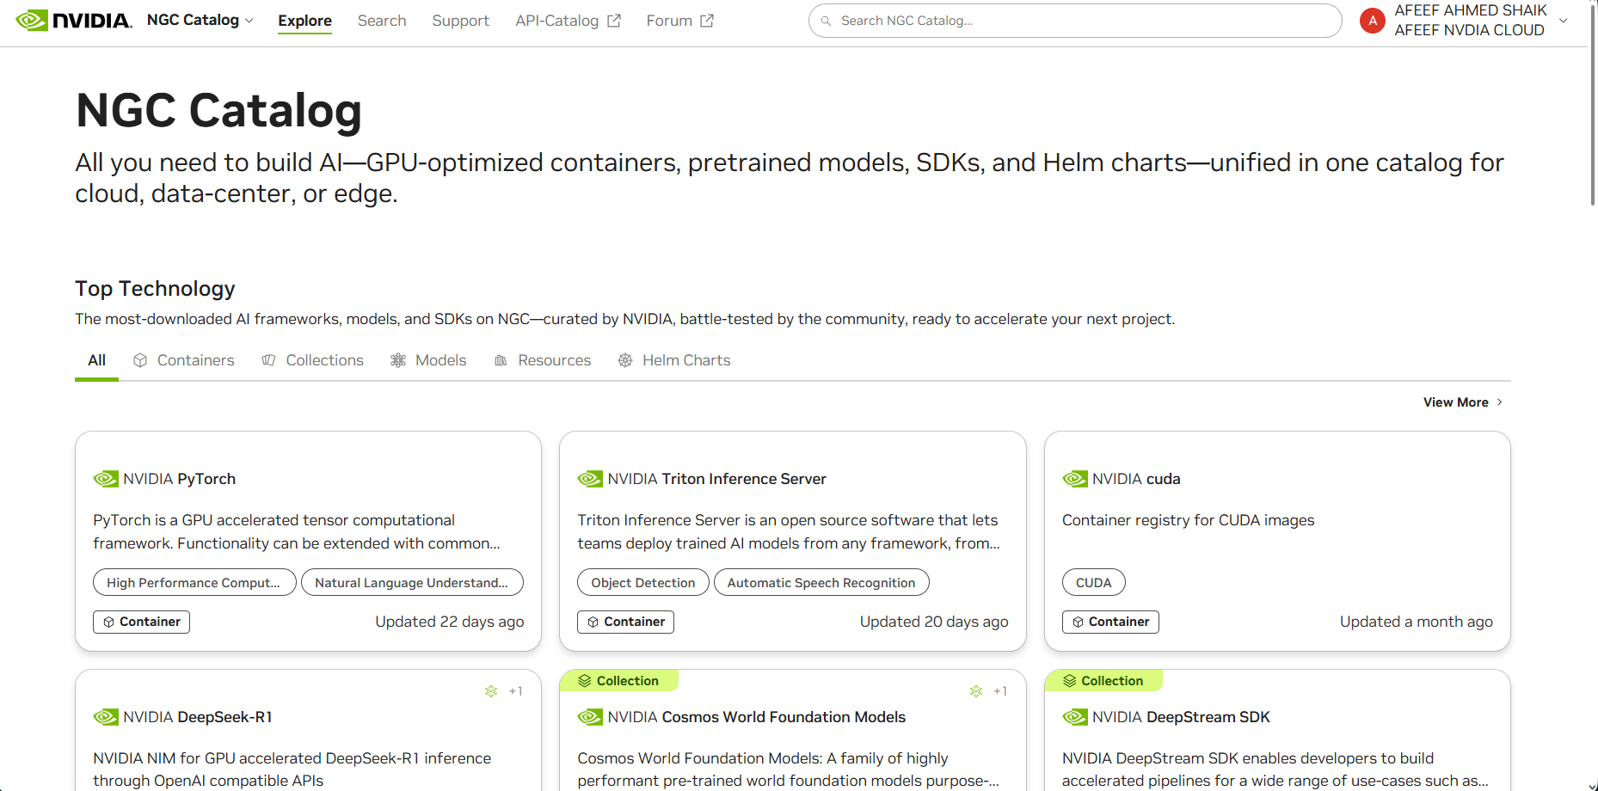
Figure 4: NVIDIA NGC USER DASHBOARD

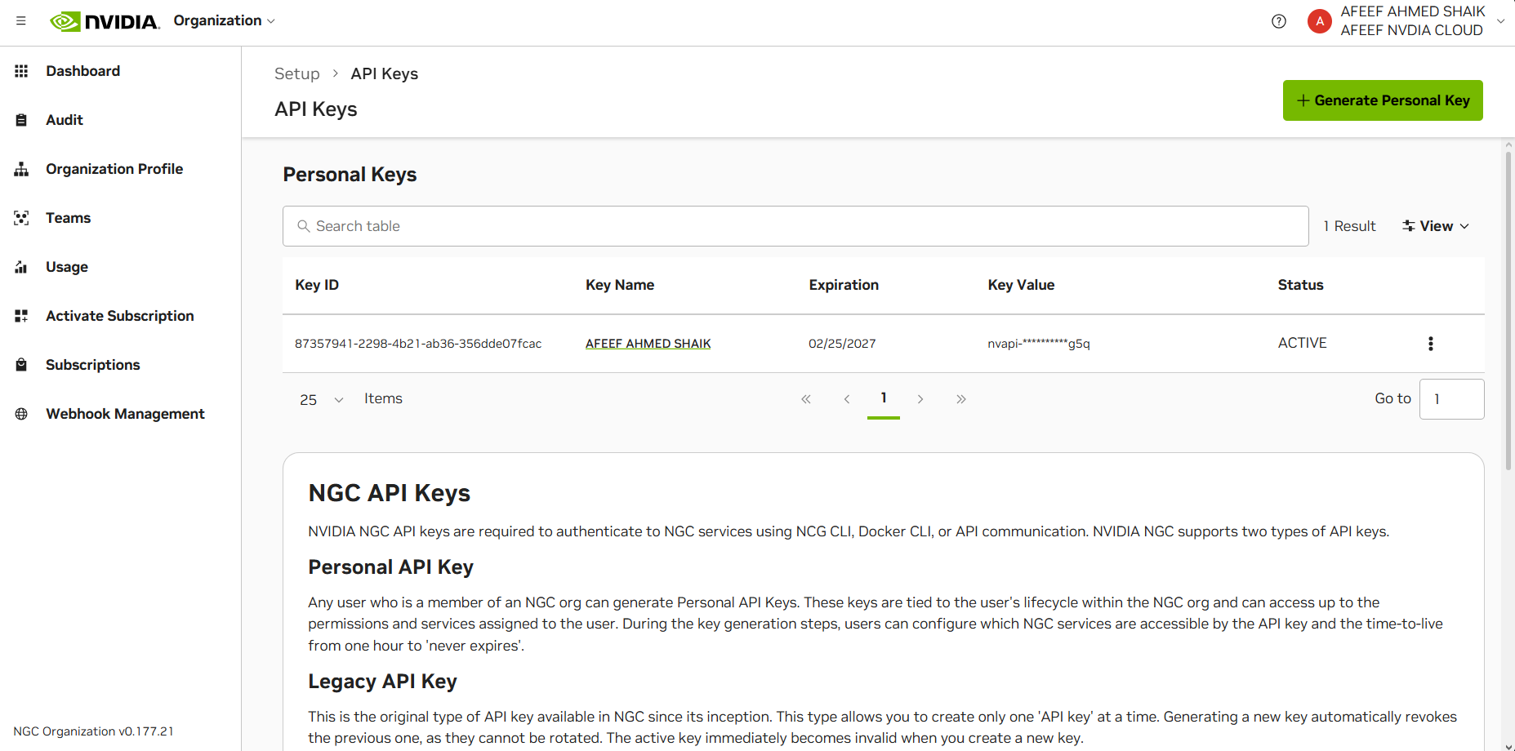
Figure 3: USER TERMINAL

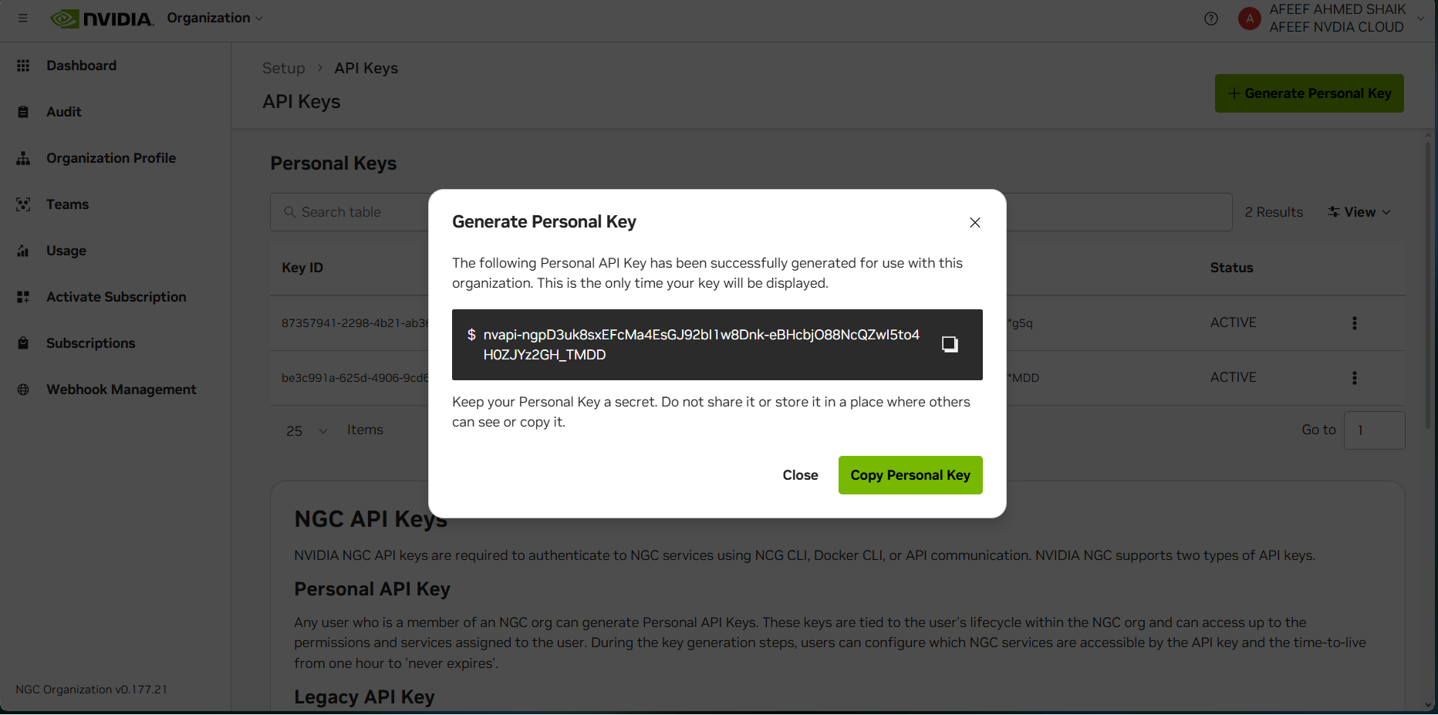
Figure 6: NVIDIA NGC API KEY GENERATION

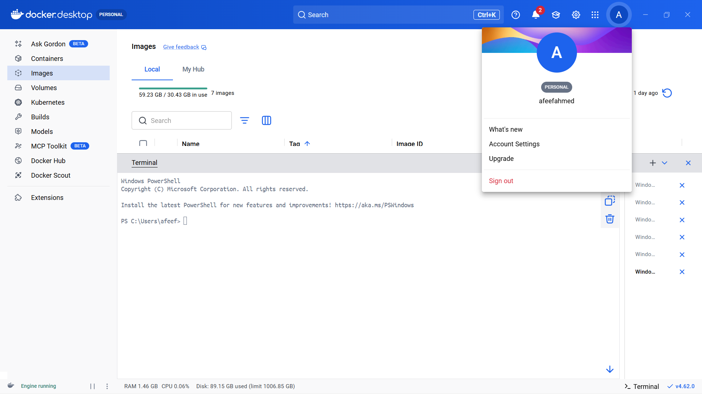
Figure 7: Docker Images Before Pulling GitHub and Friend Images

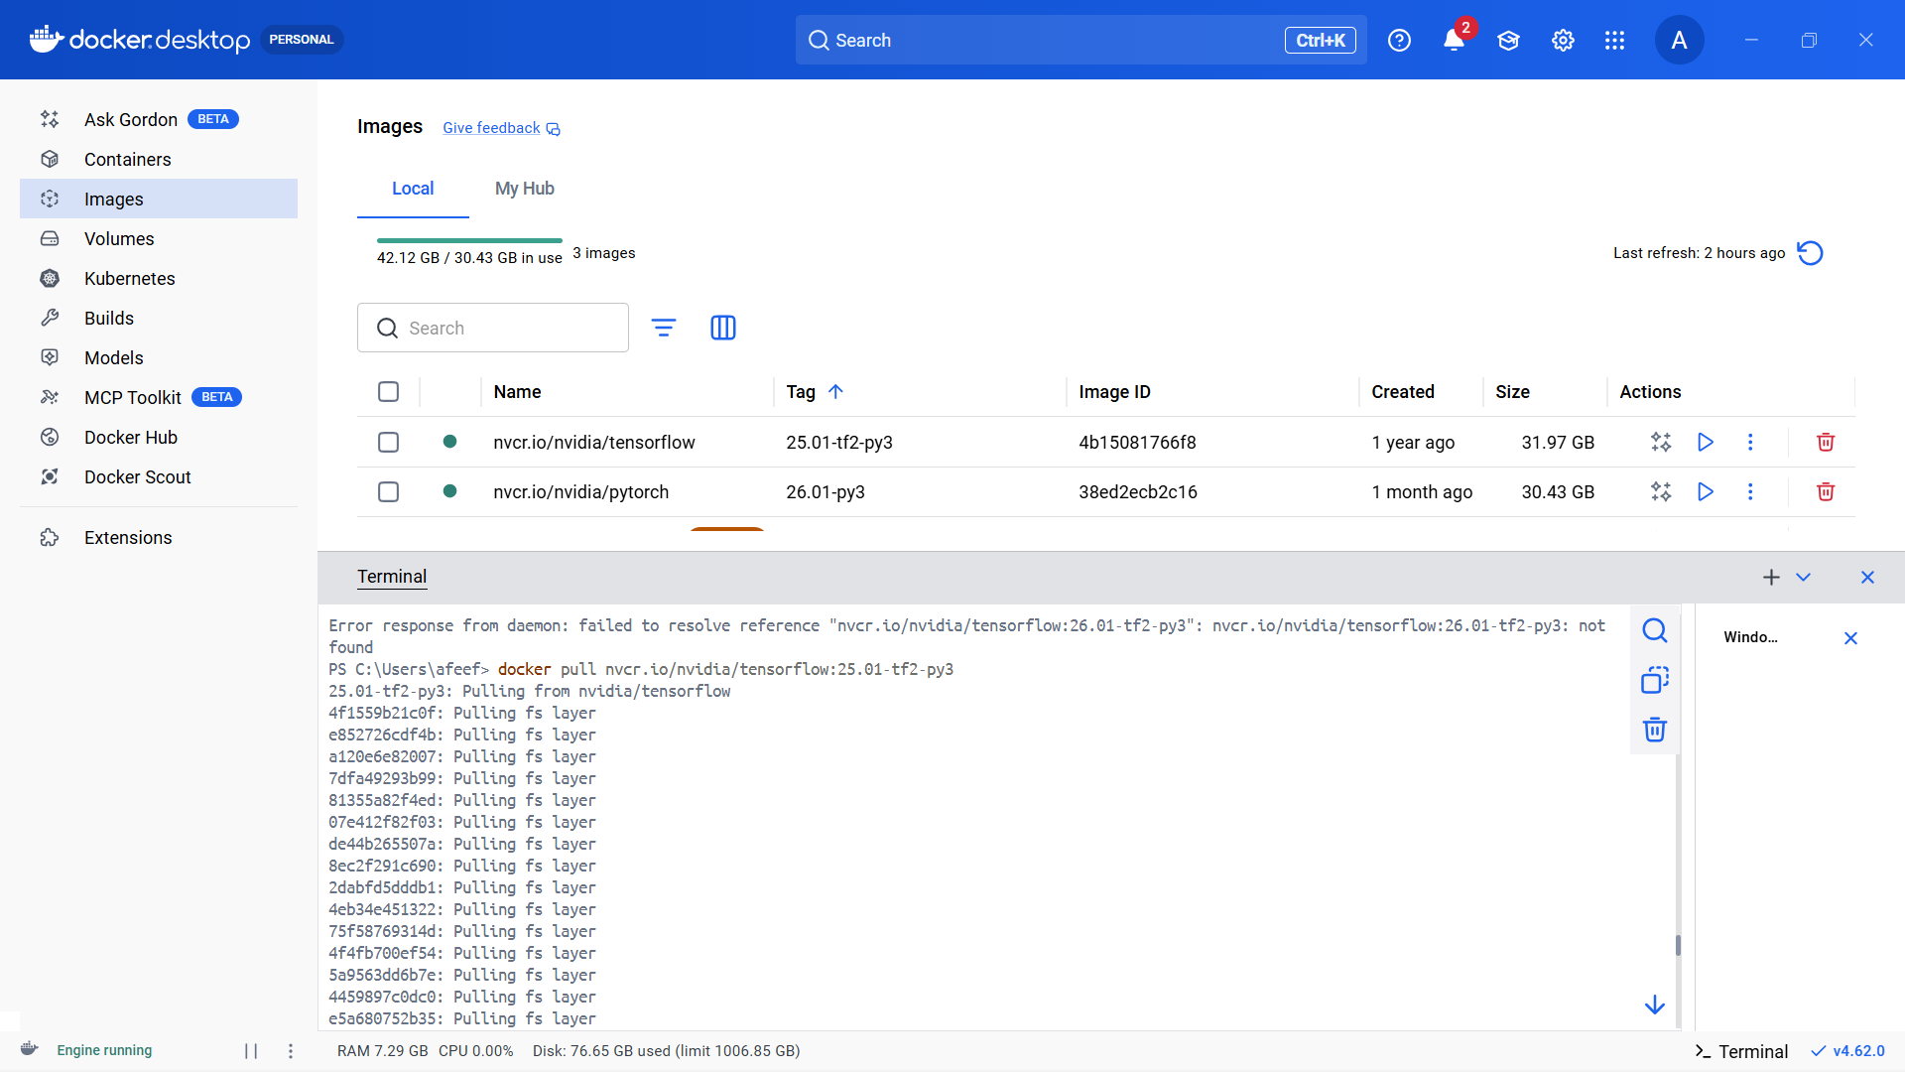
Figure 8: TensorFlow Container Pull

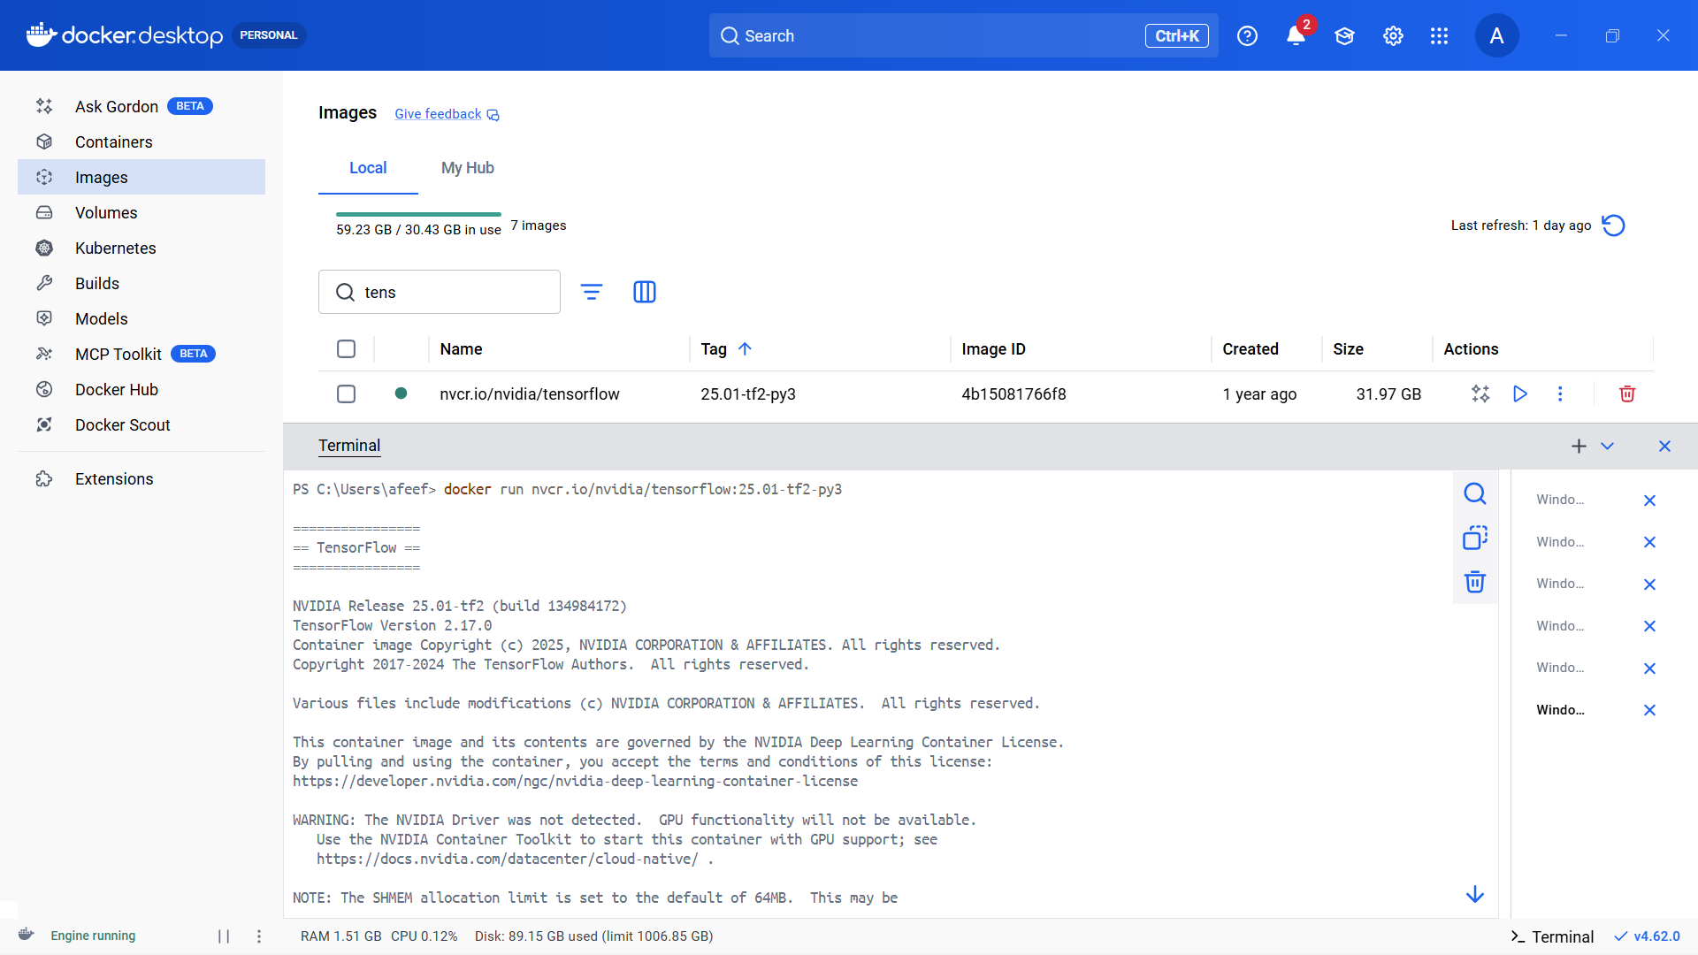
Figure 9: TensorFlow Container Run

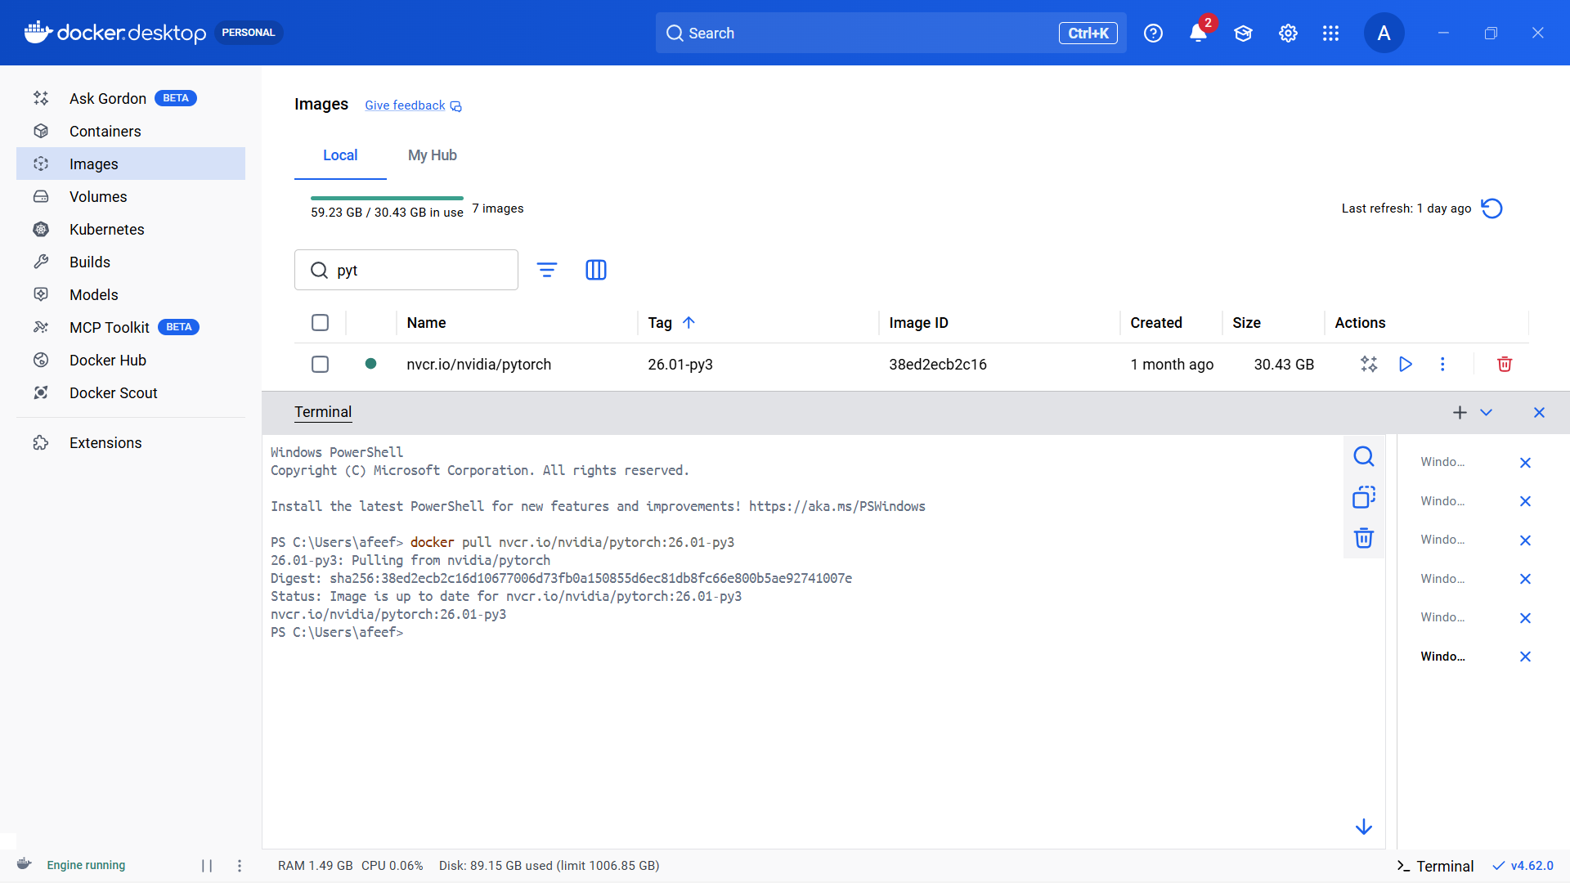
Figure 10: PyTorch Pull

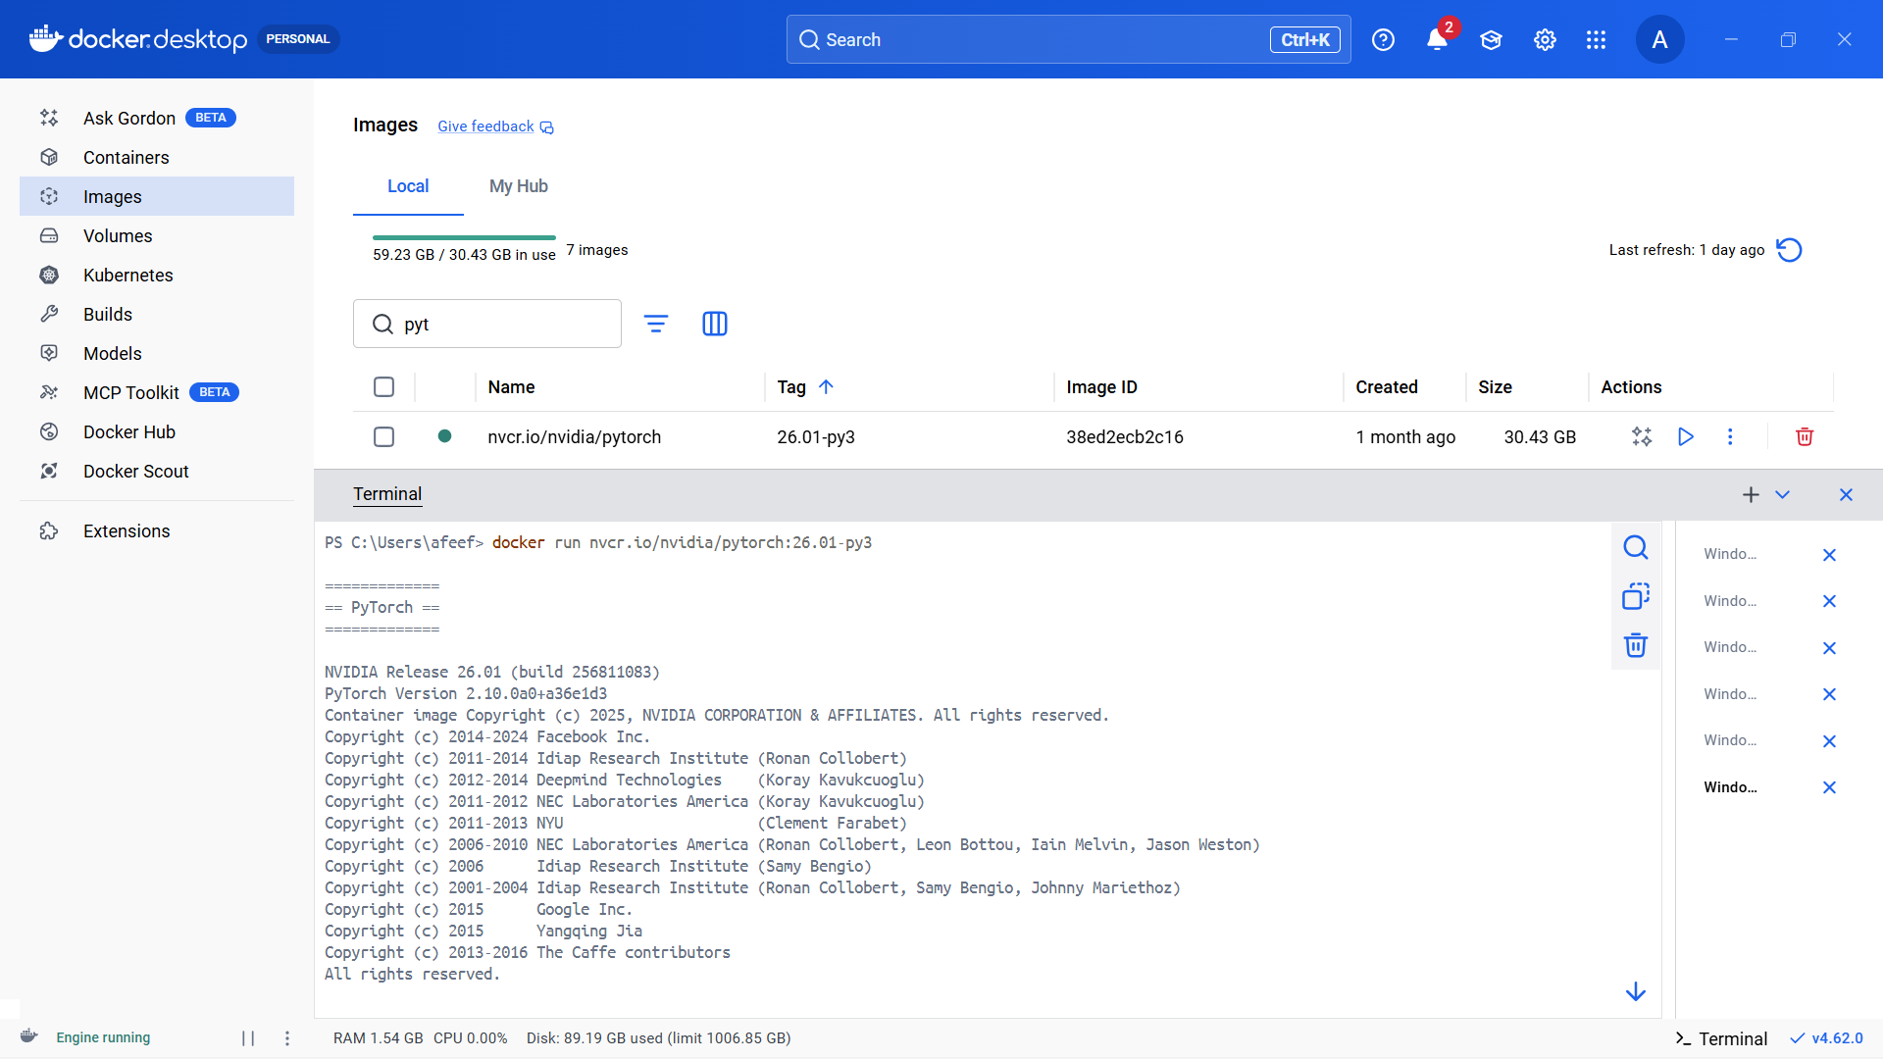
Figure 11: PyTorch Run

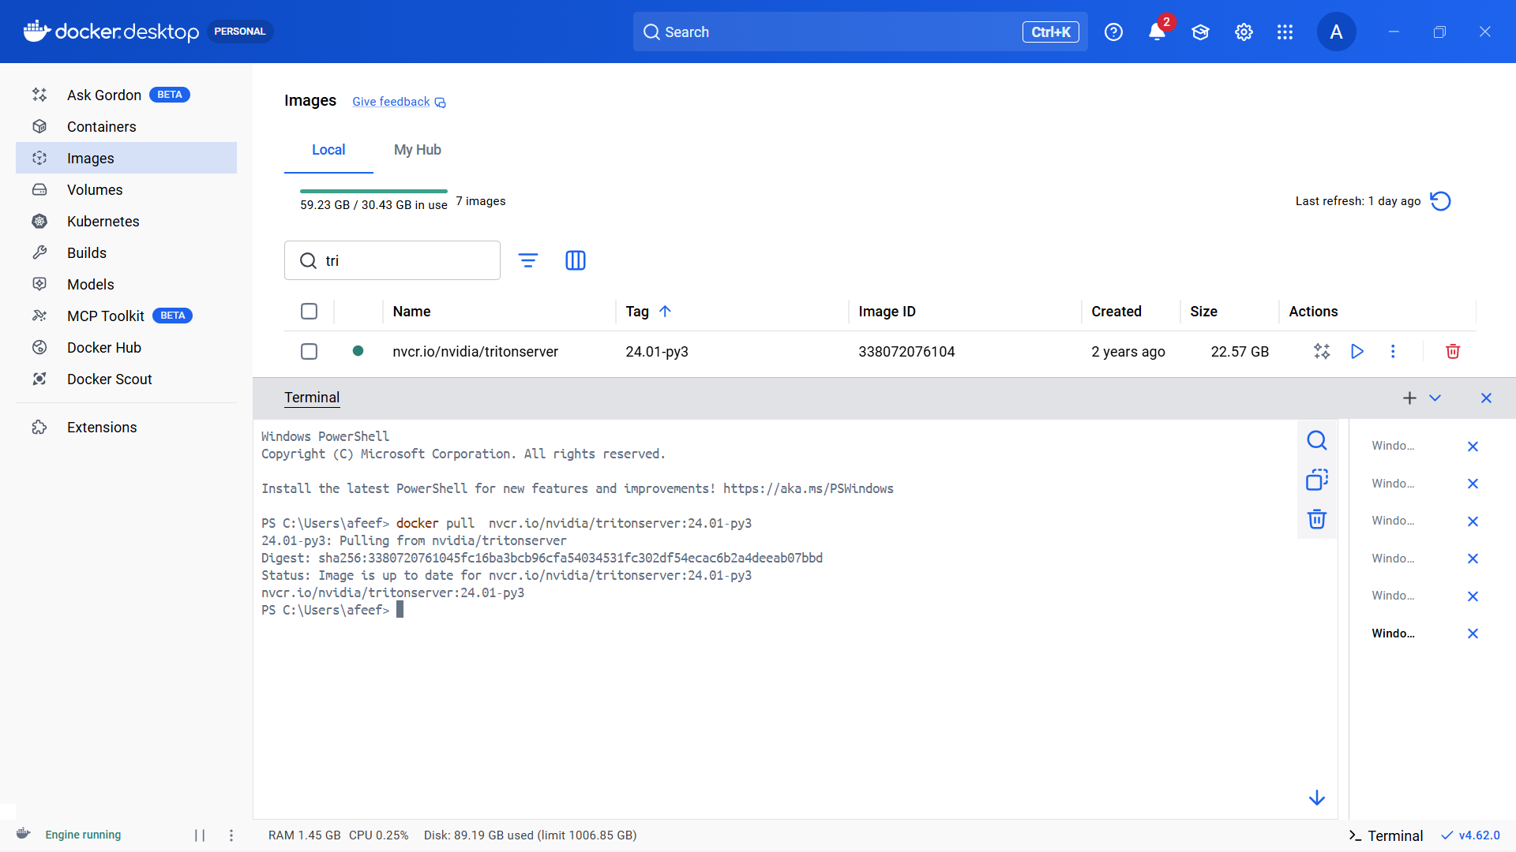
Figure 12: Use Case Container Pull

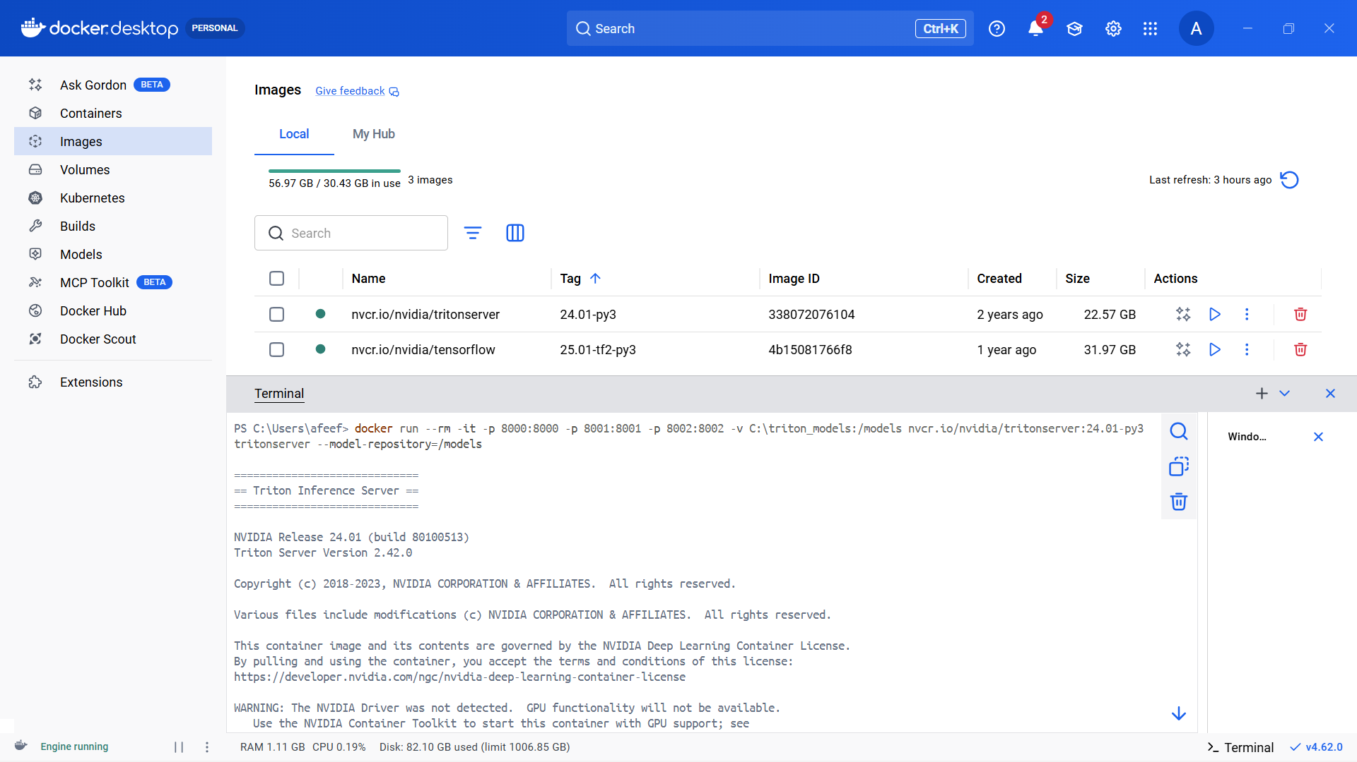
Figure 13: Use Case Container Run

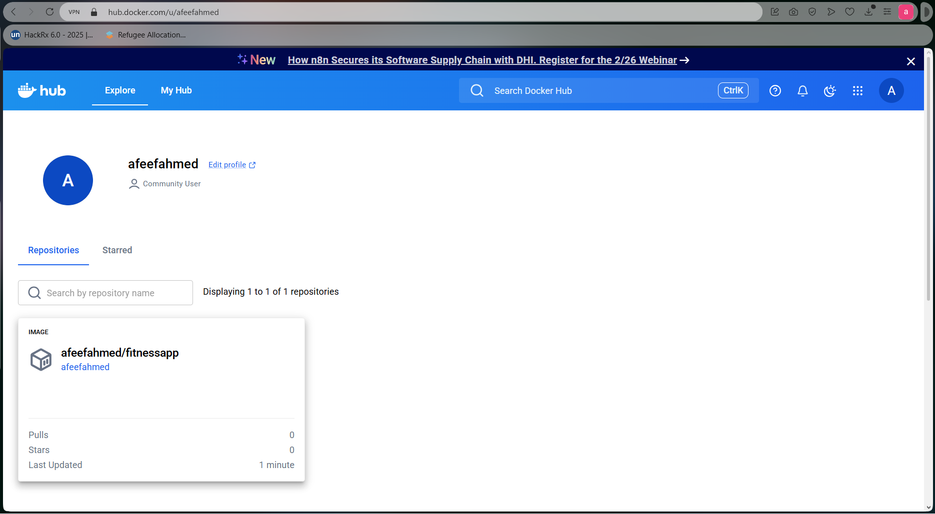
Figure 14: Self Project Pushed in Docker Hub

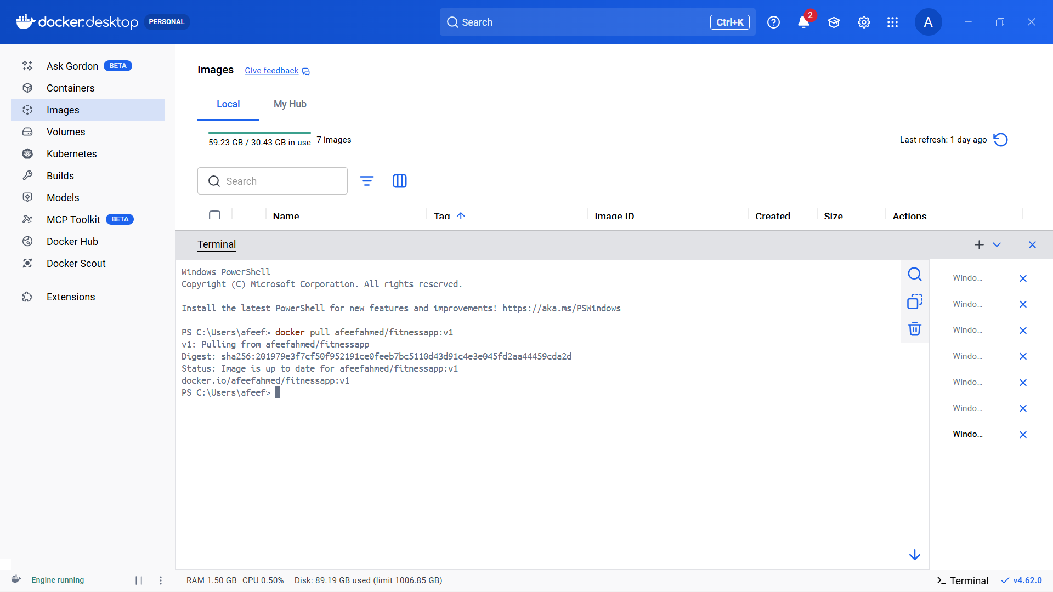
Figure 15: Pulling Self Image

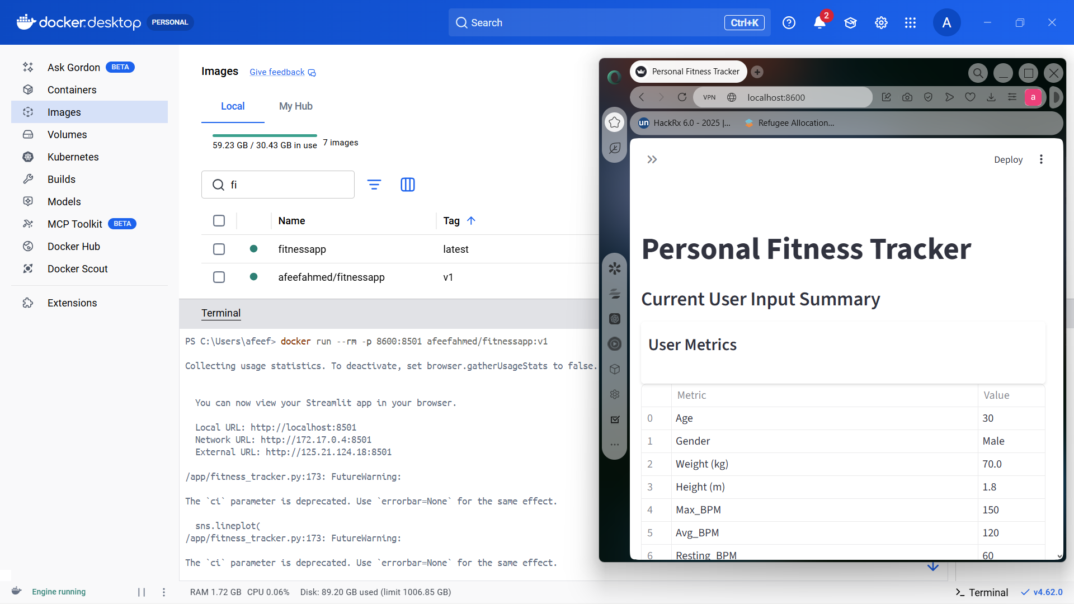
Figure 16: Running self-image

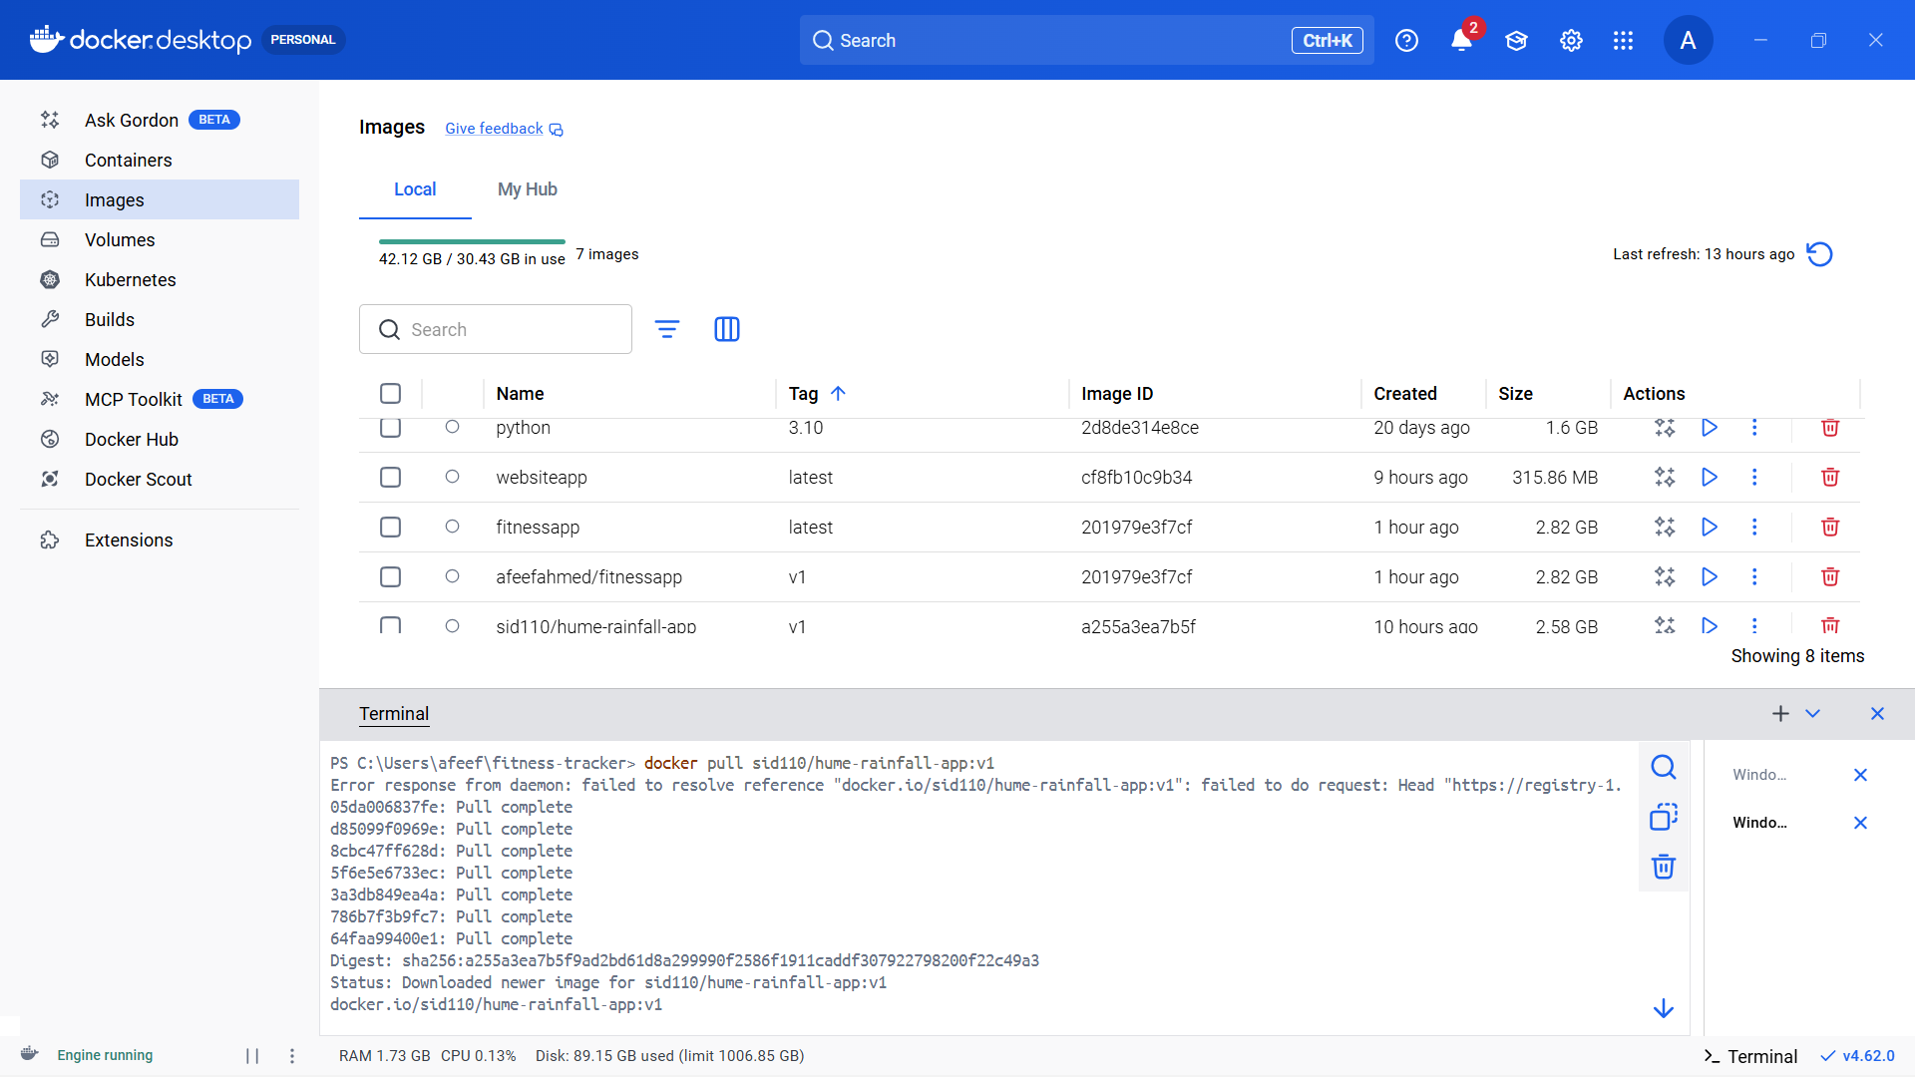
Figure 17: Pulling Friend Image

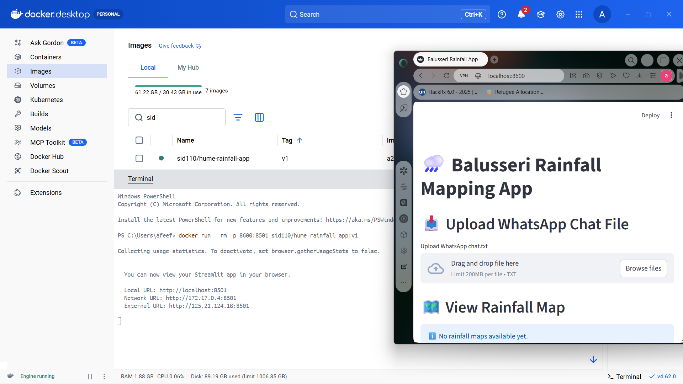
Figure 18: Running Friend Image

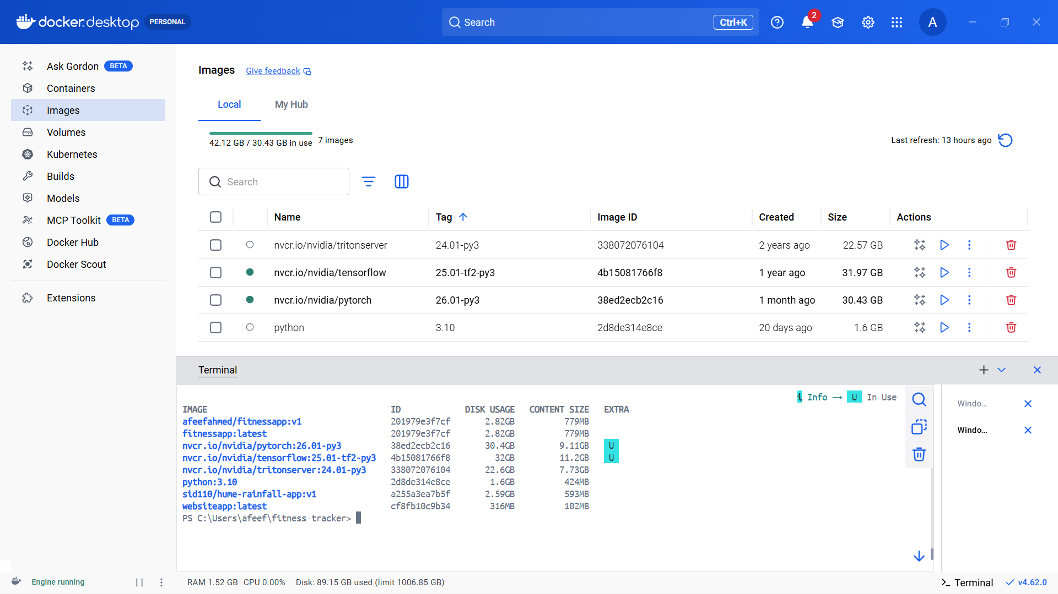
Figure 19: Docker Images After All Pulls

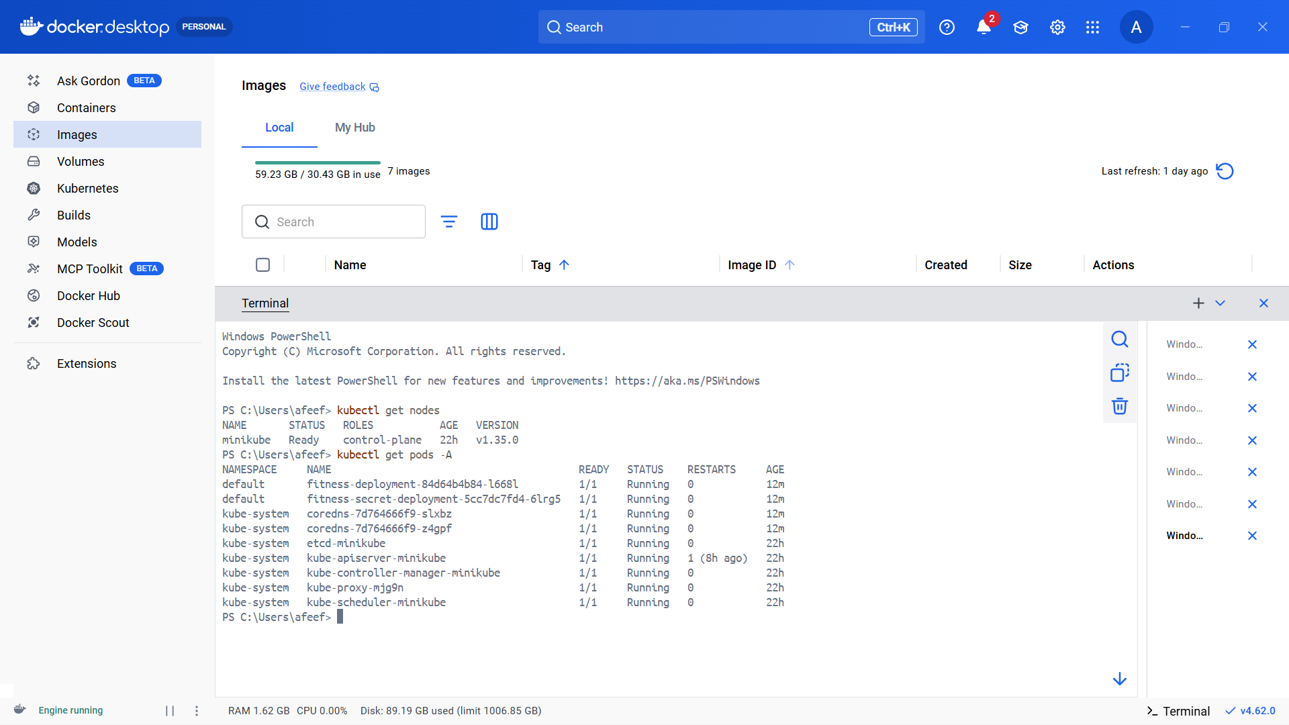
Figure 20: Checking Nodes & Pods After Installing

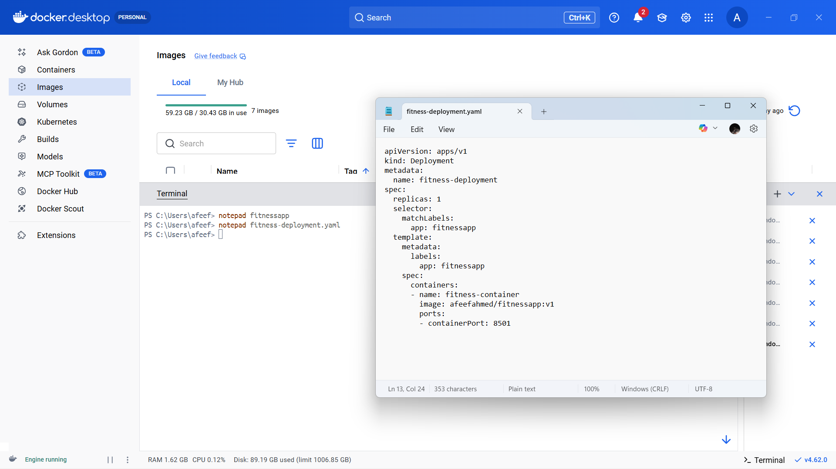
Figure 21: Yaml Defining For Self Pull

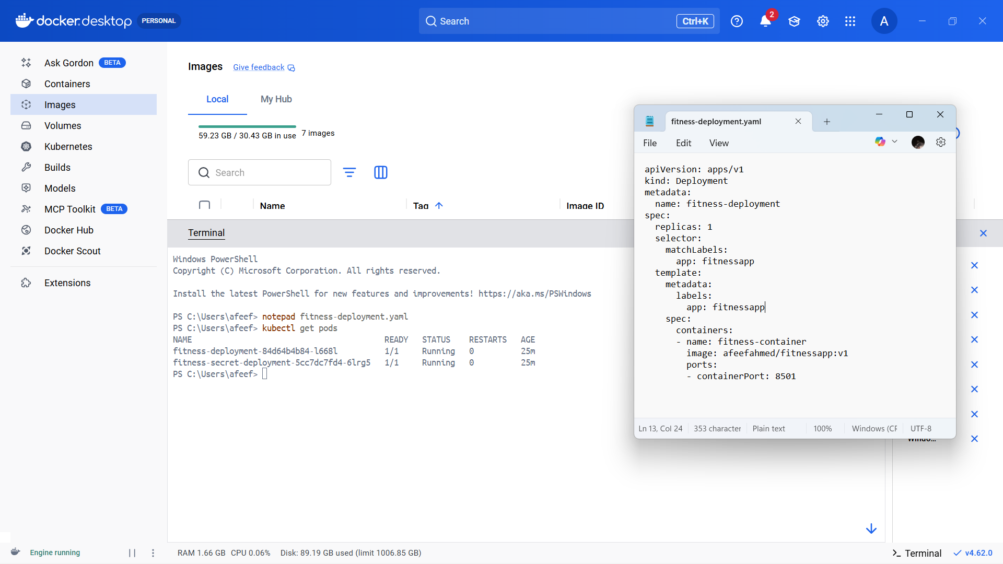
Figure 22: Self Pull Execution

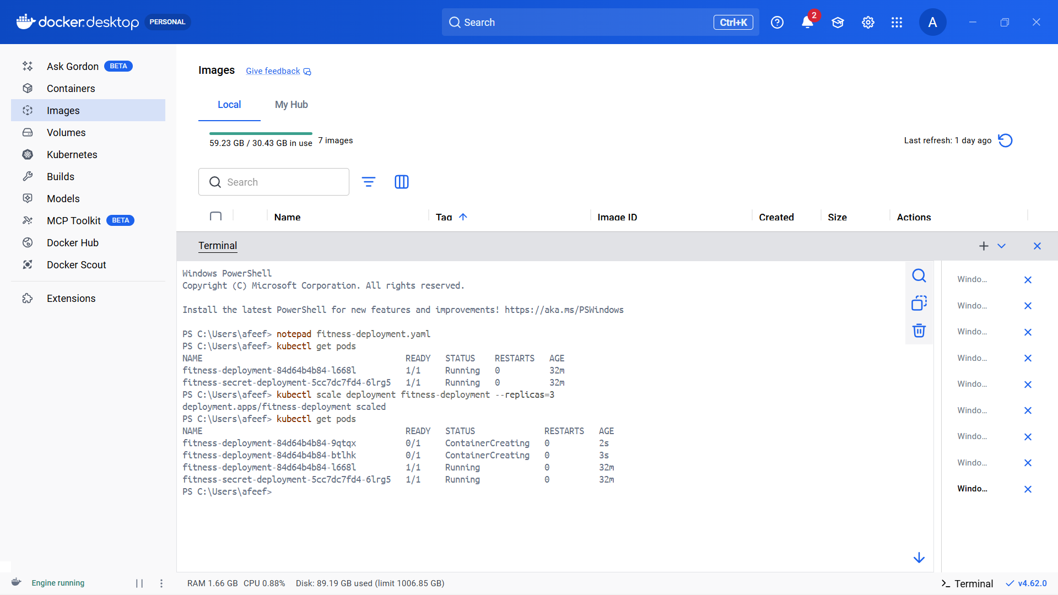
Figure 23: UPSCALE

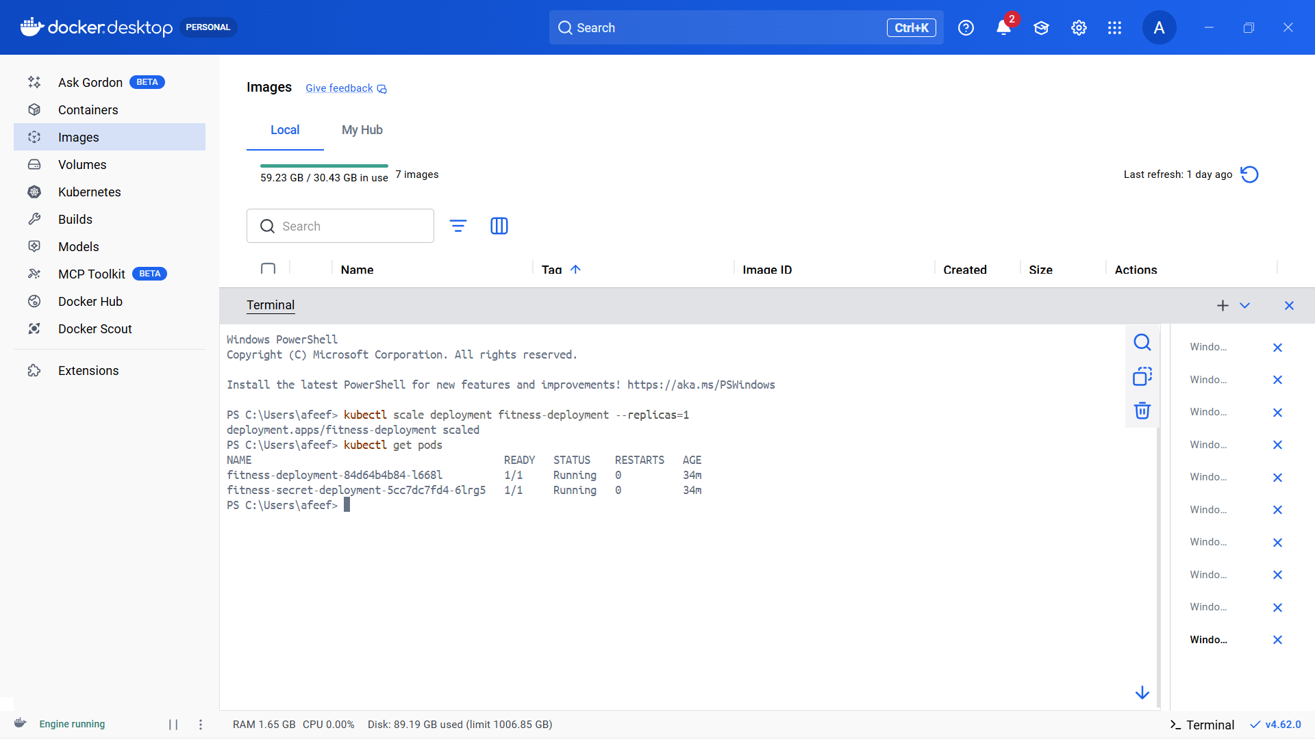
Figure 24: Downscale

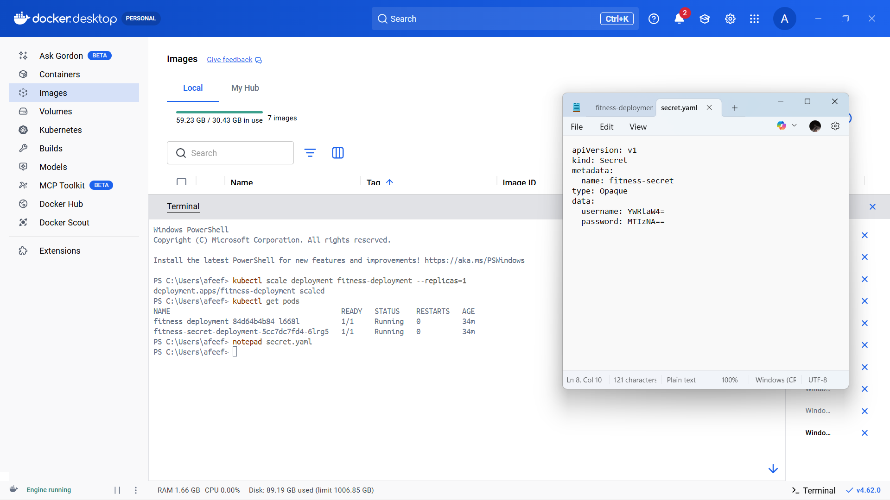
Figure 25: Secret Yaml Defining

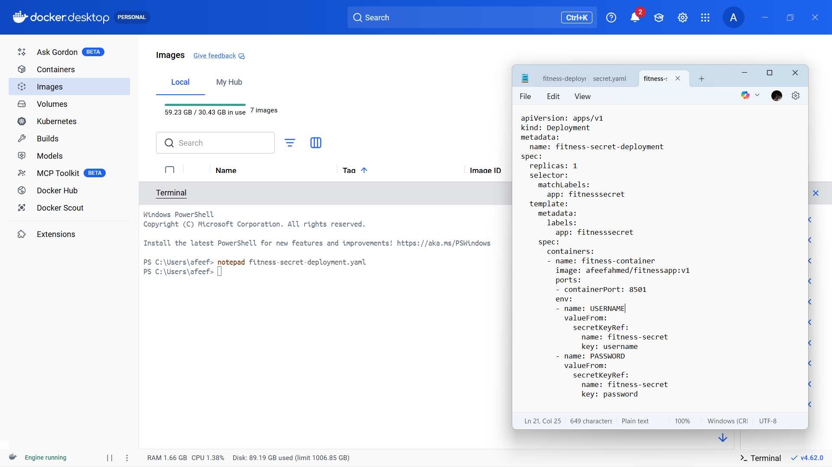
Figure 26: New Deployment Defining Kind Secret

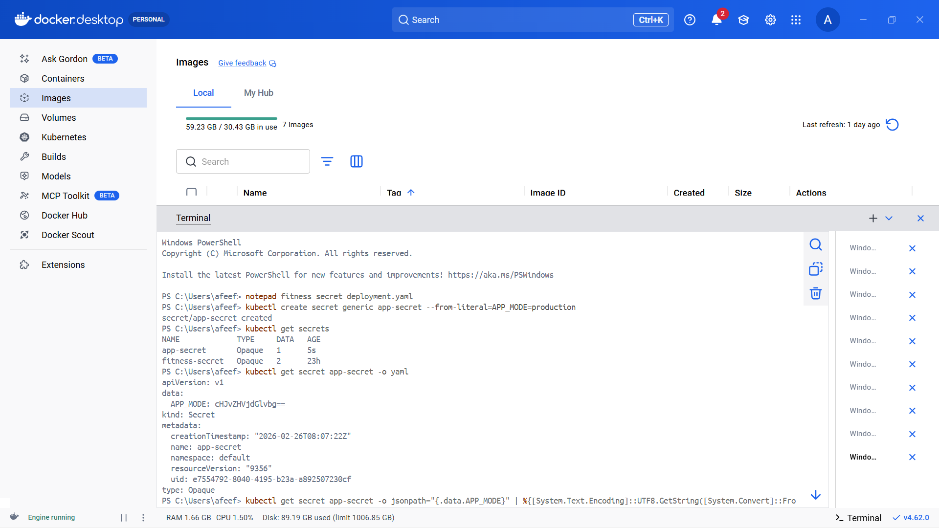
Figure 27: Getting Secret For Check

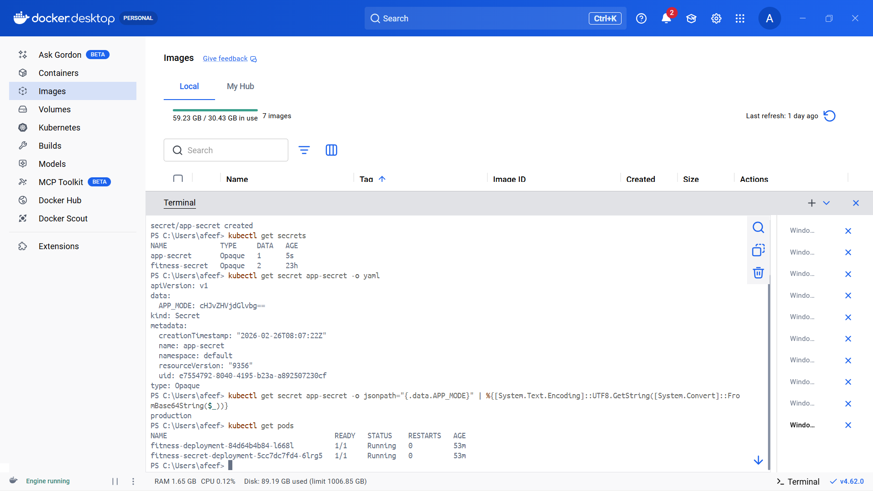
Figure 28: Secret Deployment

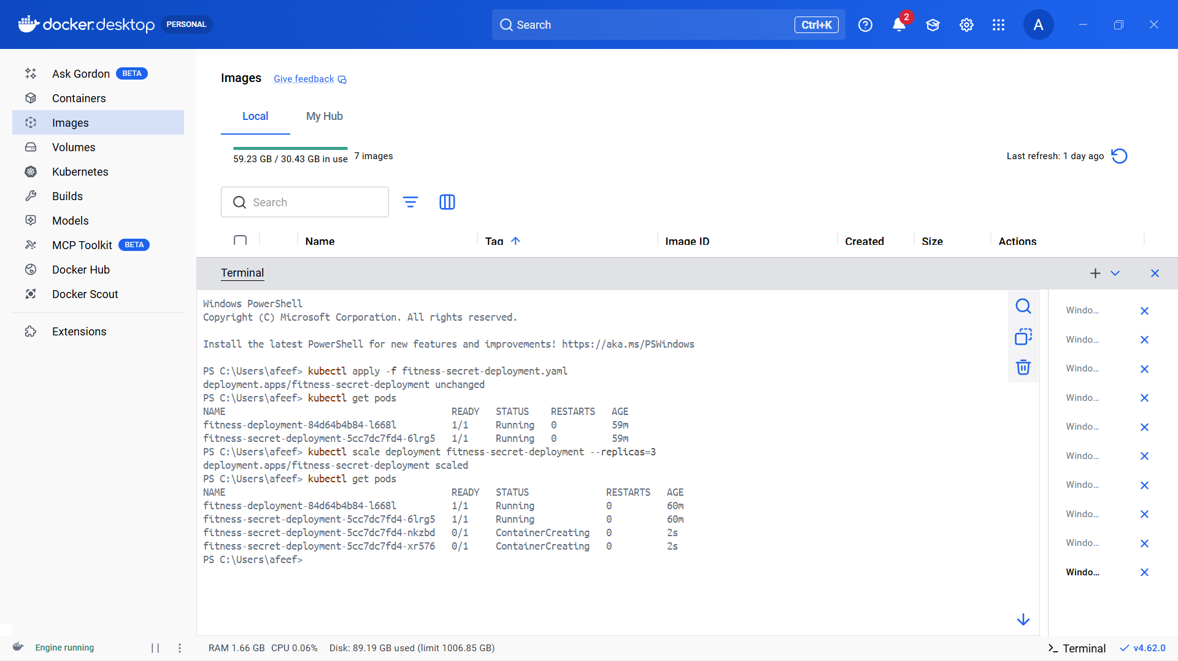
Figure 29: UPSCALE

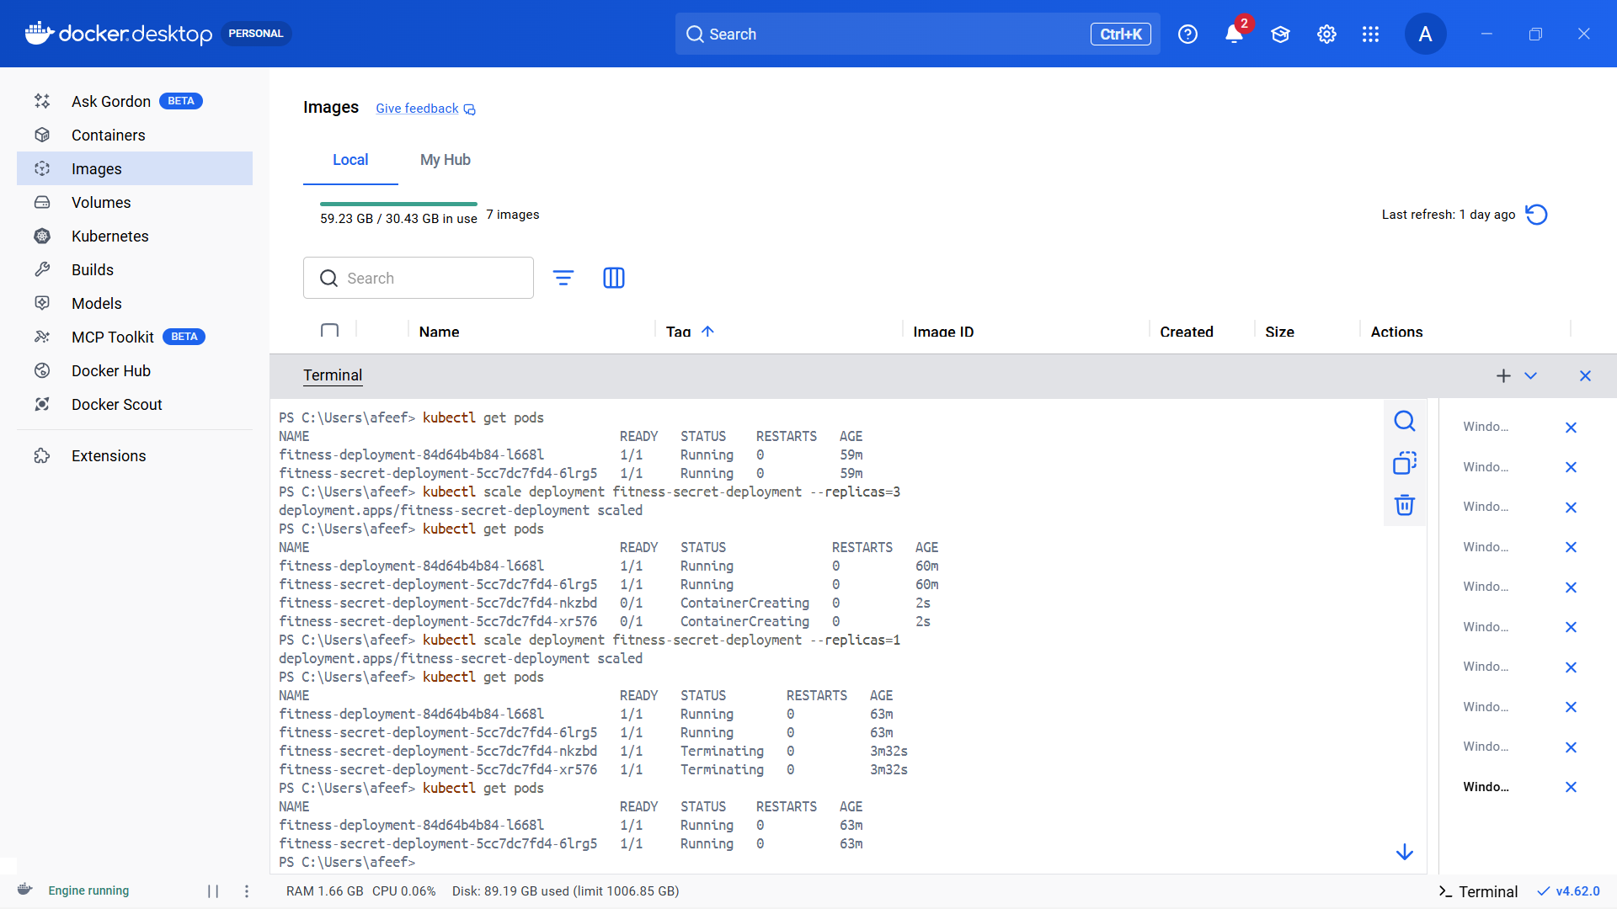
Figure 30: Downscaling

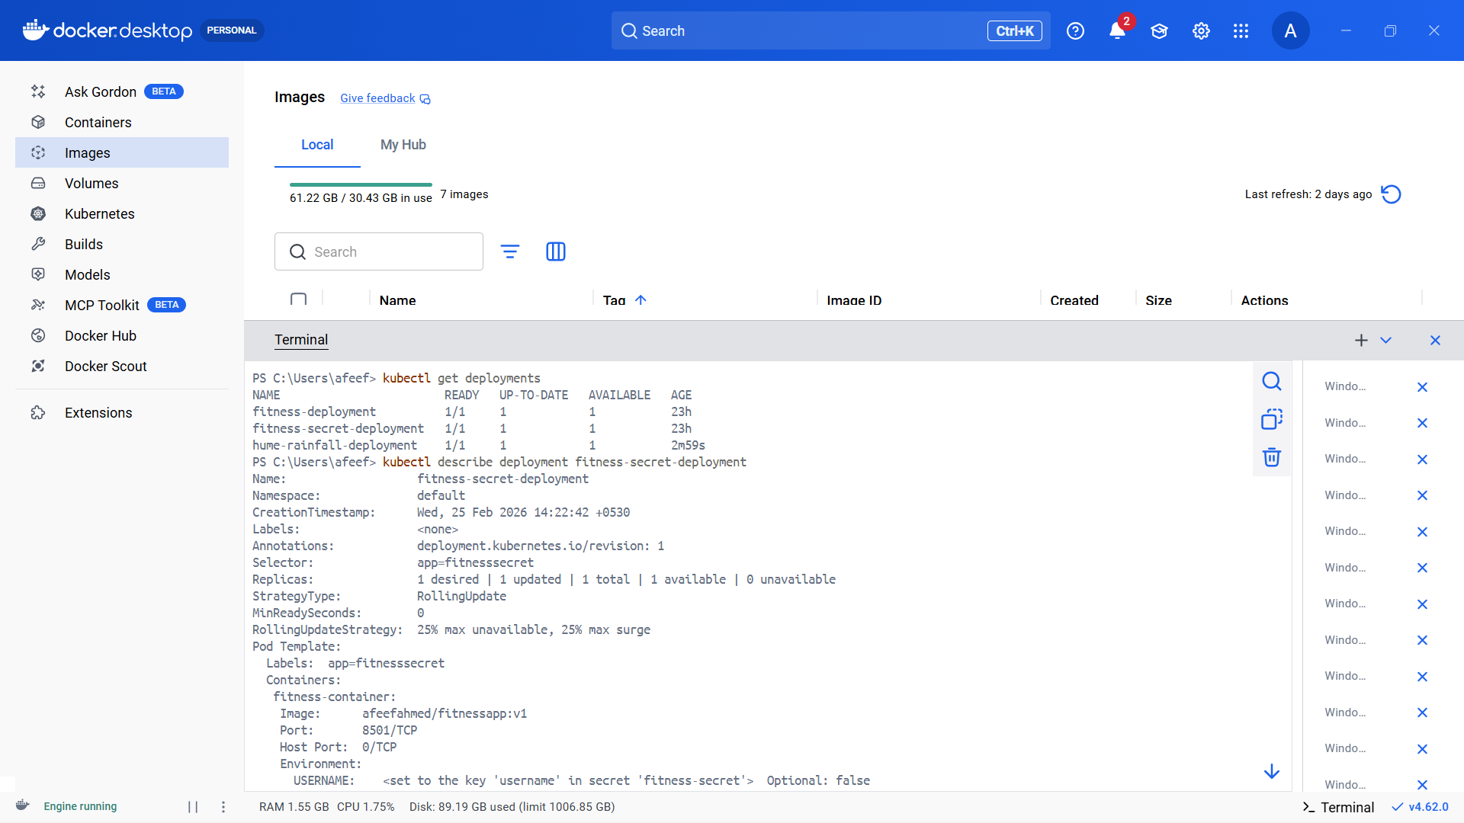
Figure 31: All Final Deployment

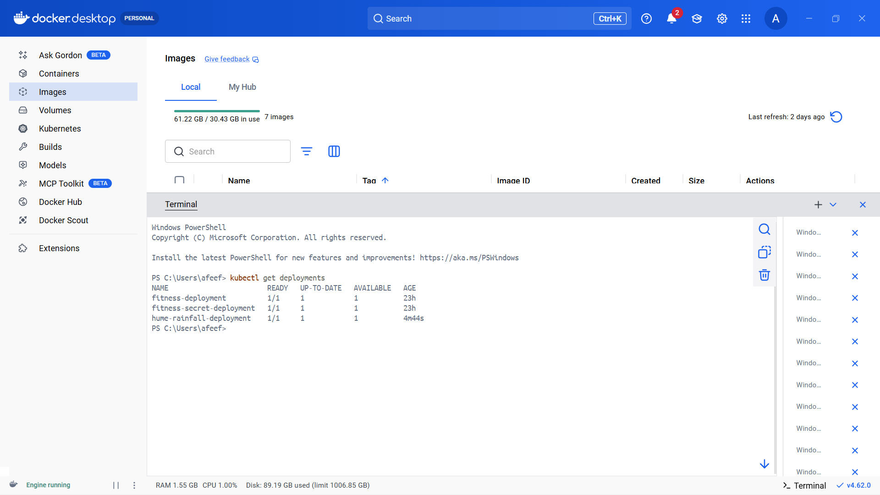
Figure 32: All Pods

